Accommodation for SOPHIA

Recommend staying somewhere in the Gloria district by Universidade de Aveiro as this is central and where we will be eating on the Monday evening. Hotels in this area range in price from budget to 4 star hotels so there is something for everyone.

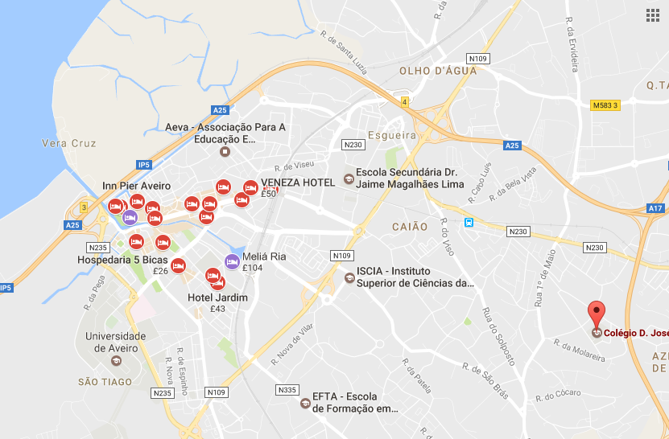

https://www.google.co.uk/maps/place/Col%C3%A9gio+D.+Jos%C3%A9+I/@40.6388888,-8.6443112,14z/data=!4m8!1m2!2m1!1shotels!3m4!1s0x0:0xc77611ecd769c2ba!8m2!3d40.6325679!4d-8.6062753

Travel time to the Colegio D. Jose I is about 10 minutes in a car, or 30-40 minutes by public transport, or 50 minute walk.

Some hotels listed below have offered a rate for attendees of SOPHIA Meeting, email them with SOPHIA Network Meeting 2017 as the reference to book your room.

4 stars hotels

- Hotel Moliceiro http://www.hotelmoliceiro.pt/en/msg.contactform.thanks.html

11 minute drive to Colegio D Jose
44 minutes public transport

Quarto Single €82.50
Quarto Double €97.50

We are writing to confirm our availability from 2nd to 5th of July. We also inform that all reservation requests will be subject to availability.

Attached to the e-mail you will find the price list.

The rates include:

- Welcome drink - Sparkling wine or Port wine with ovos moles (traditional sweets of Aveiro);
- Breakfast Buffet at Bar Moliceiro;
- Tea and coffee facilities with biscuit in the room (replenished daily);
- Wi-Fi access in all areas of the hotel;
- Free access to Holmes Place Club, gym, swimming pool, jacuzzi and Turkish bath (5 min. drive from the Hotel).

* If the guests have any food restriction (gluten free, no sugar, vegetarian, vegan), please let us know in advance so we can meet your needs.

All our rooms are modernly equipped with satellite TV, free internet access, air conditioning, safe, mini-bar, direct telephone and hair dryer. At our hotel you can also find a Bar with live piano music every Fridays and Saturdays.

We also have laundry and room service. On the ground floor you may find our Net Office of free use and with internet access.

As we do not have a restaurant, we can advice some of the best traditional restaurants nearby, according to the guests preferences.
Our Hotel stays about 10mn from Aveiro University, walking.
Nearby you can find the best and typical Restaurants; pharmacies; Banks; Historical Zone; Museum and Shopping Centre.
About 10-15mn, by car, stays the Beach area.

Conditions:

Check-in after 3:00 pm | Check-out until 1:00 pm.

Please, inform us the name of the Conference in order to provide a code to the guests. The requests should be made by e-mail. We also inform that the payment will be made directly by the guests at the check-out time and the reservations must be guaranteed with a credit card details (number and expiry date).

- Melia Ria Hotel & Spa https://www.melia.com/en/hotels/portugal/aveiro/melia-ria/index.html

10 Minute drive to http://www.coldjose1.pt/index.php/organigrama-da-instituicao/localizacao

35 mins public transport

50 minute walk

> Single room: € 80,00 / night (VAT included)
> Double room: € 90,00 / night (VAT included)

General conditions:
- Meal Board: Bed & Breakfast
- Free Access to the internet (wifi)
- Rates valid only for this request
- Direct payment for each guest
- NET Rates
- This rates are exclusive for direct reservations by e-mail (melia.ria@meliaportugal.com) or telephone (+351 243401000).

Other services available at the hotel (not included):
- Health Club (heated indoor swimming pool, Jacuzzi, Sauna, Turkish Bath and Gym): €10,00 / person / day
- Mandatory use of bathing suit, swimming cap and slippers (not included in the rate)
-Parking/Garage: 6,00€/day

To reserve, they just need to mention the name of the conference by email or telephone.

The confirmation depends of our availability for that dates.

3 stars hotels

- Hotel Imperial http://www.hotelimperial.pt/pt/contactos/

- Hotel das Salinas http://hoteldassalinas.com/en/contacts/

11 minute drive
45 mins public transport

*Standard single room – 50€/room/night
*Standard double room – 65€/room/night
* Studio single room – 55€/room/night
*Studio twin room – 75€/room/night

The price includes breakfast buffet and free access to Internet wifi.

We are at your full disposal for any information.

Email reservas@hoteldassalinas.com giving SOPHIA Network Meeting 2017 as the conference to get these prices.

- Hotel Afonso V http://www.hotelafonsov.pt/en/contact

10 minute drive
45 mins public transport

- Executive Single Room – 57,00 € / night / room (1 person)
- Executive Double/Twin Room – 79,00 € / night / room (2 persons)
(Room with double bed or 2 single beds, complet bathroom with hairdryer, work desk, safety deposit box, air Conditioning, telephone, radio, cable TV, wake up service/alarm clock, smoking or non smoking)

- Standard Single Room – 54,00 € / night / room (1 person)
- Standard Twin Room – 76,00 € / night / room (2 persons)
(2 single beds, complet bathroom with hairdryer, work desk, safety deposit box, air conditioning, telephone, radio, cable TV, wake up service/alarm clock, smoking or non smoking)

- Económic Single Room – 50,00 € / night / room (1 person)
- Económic Double Room – 68,00 € / night / room (2 persons)
(1 double bed, smaller room with wc and shower, safety deposit box, air conditioning, telephone, cable TV, wake up service/alarm clock, smoking or non smoking)

I also inform that to these values will be made a discount of 10%.

Breakfast Buffet – Included
All taxes included

Email info@hotelafonsov.pt with SOPHIA Network Meeting 2017

